

Discards accounting in EwE
Implemented for DiscardLess / MINOUW by Ecopath International Initiative
Joe Buszowski, Villy Christensen, Mark Platts, Jeroen Steenbeek
Document version 1.1, 1 March 2017
Software version 6.6, 1 March 2017

Ecopath
Internally, Ecopath was already accounting for discards, but this accounting was not exposed to the EwE desktop software user. New Ecopath output tables have been added that provide Discard mortality and Discard survival estimates by fleet and group. These output tables are accessed via Navigator > Ecopath > Output > Fishery (Figure 1).
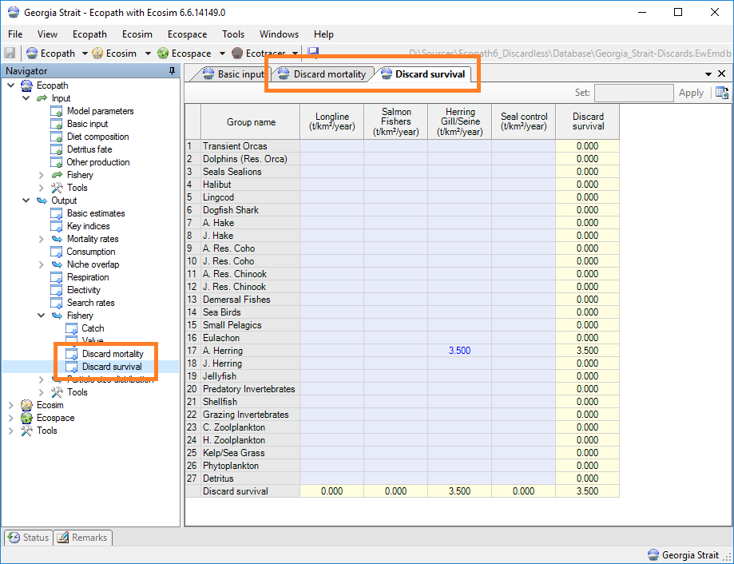
Figure 1 - New Ecopath discards tables
Note that the Azores team has expressed the need to add a column to the discard fate table to allow part of the unwanted catch to be landed, and that this portion could be provided an economic value different from the value of the wanted landings.
Valuing exported discard fate (representing the value of unwanted catch) is necessary to explicitly represent the implications of EU landings obligations in EwE. The current EwE setup is able to account for this costing in an indirect way by splitting fleets, etc. Implementation uncertainty is high regarding this point, mostly because the Ecosim and Ecospace effort gravity models will be greatly affected. A proper implementation is estimated to take 1 to 2 weeks to implement, and a week to test. The EwE development budget under DiscardLess and MINOUW is unfortunately insufficient to address this change. EwE researchers at Stockholm University have expressed interest in writing a follow-up proposal to implement this specific feature.

Ecosim
A series of discards accounting changes have been made to Ecosim.

Expose discard accounting
The internal accounting for discards and landings within Ecosim is now represented in the EwE desktop software via new discards-related graphs (Discards mortality and Discards survival) in the Ecosim group plots, and in the CSV files that Ecosim can write to disk. The new group plots can be found under Navigator > Ecosim > Output > Ecosim group plots (Figure 2). The CSV output can be obtained by either auto-saving Ecosim, or manually saving Ecosim results to CSV file in the Ecosim group plots window.
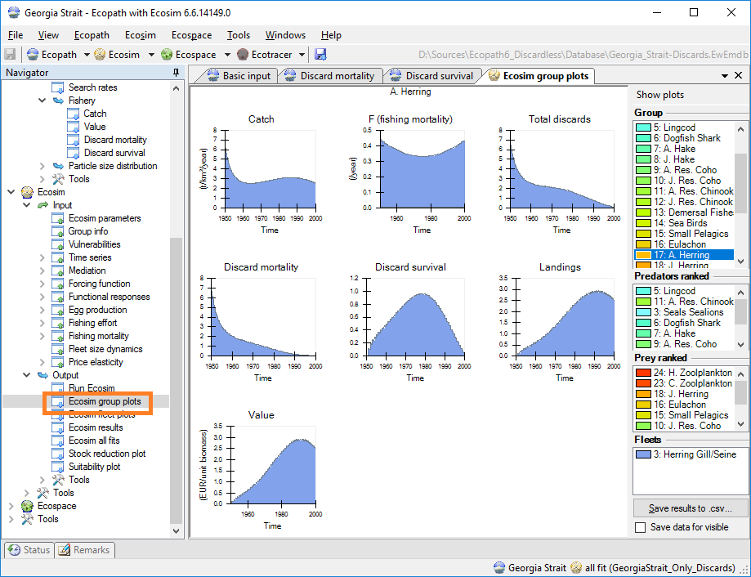  Figure 2 - New Ecosim discard plots, per group |  | 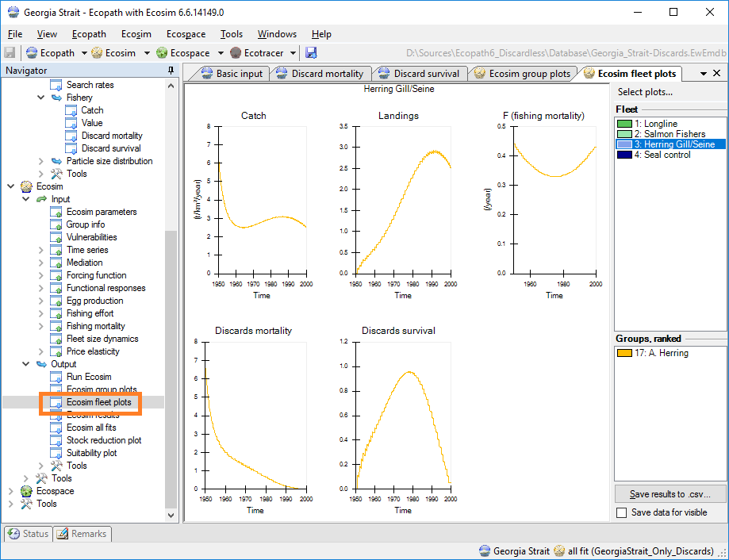  Figure 3 - New Ecosim discard plots, per fleet

In addition, a fleet-centric series of Ecosim plots have been added, which can be found under Navigator > Ecosim > Output > Ecosim fleet plots (Figure 3). The CSV export option in this screen only writes fleet-related Ecosim outputs to CSV file.

Allow varying discards in Ecosim
The ability to represent variations in discard strategies, either by varying the proportion discarded, or by varying discard mortalities, were added through two new types of absolute driver time series: Discard Proportion (type 10) and Discard Mortality (type 11).
Discard Proportion time series are used as multipliers to the base discard proportion as entered in the Ecopath input parameters for a given gear + group combination.
Similarly, Discard Mortality time series are used as multipliers to the base discard mortality rate as entered in the Ecopath input parameters for a given fleet + group combination.
The new discards time series introduce new concepts to the ancient Ecosim time series logic:
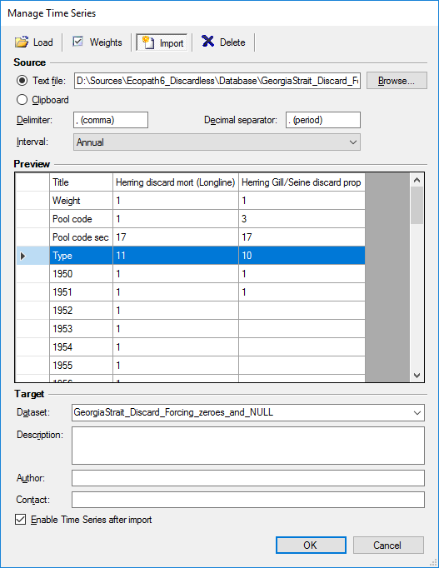
Figure 4 – Importing the new discards driver time series into Ecosim
- Discard proportion and Discard mortality apply to specific gear + group combinations. As such, these time series require specification of both a fleet (first pool code) and a group (second pool code) on import, as shown in see Figure 4.
- To be able to entirely shut down discarding, both new time series types accept 0 as an actual value. This is a deviation from the existing time series protocol, where 0 is used as a ‘no data’ value. As a generic rule, all time series csv files should be created in Excel using empty cells for ‘no data’ values, which Ecosim will resolve properly upon import (see Figure 4, last column. last visible rows)

Using landings and discards for model fitting
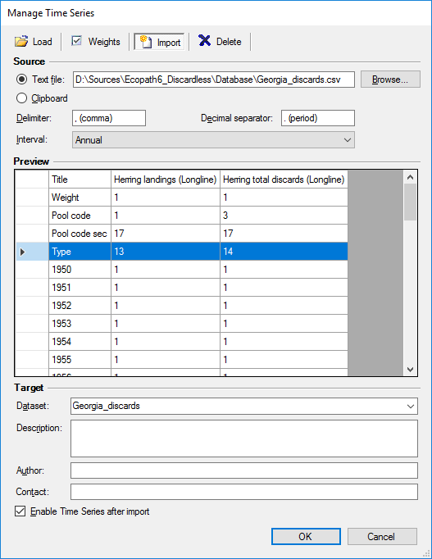
Figure 5 - Importing the new landings and discards reference time series
Ecosim has gained the ability to include reference time series of landings and discards for model fitting purposes.
The Landings time series (type 13) is a reference time series that specifies the absolute landings of catches of a given functional group by a given fleet, over time. Landings time series accept 0 as valid values.
The Discards time series (type 14) is a reference time series that specifies the total discards (regardless of discard survival) of a given functional group by a given gear over time. Discards time series accept 0 as valid values.
New fitting-related graphs of Landings and Total discards were added to the Ecosim group plots (Figure 2) and fleet plots (Figure 3). Both time series types have been included in the model fit Sum of Squares calculations, and the Ecosim All Fits plots interface has been extended to display these time series when present.

Ecospace
The spatial-temporal model has been extended to incorporate Ecosim discards forcing into its calculations. This connection is not enabled by default; to enable Ecosim discards forcing in Ecospace go to Navigator > Ecospace > Input > Ecospace parameters, and under the Time Series heading at the bottom, check “Use Ecosim discards forcing” (see Figure 6). This option is only enabled if Discards driver time series are present.
The Ecospace run interface has been extended with the display of Total discards maps for each functional group. These maps can be written to disk during an Ecospace model run as part of the Ecospace auto-save logic (Figure 7).
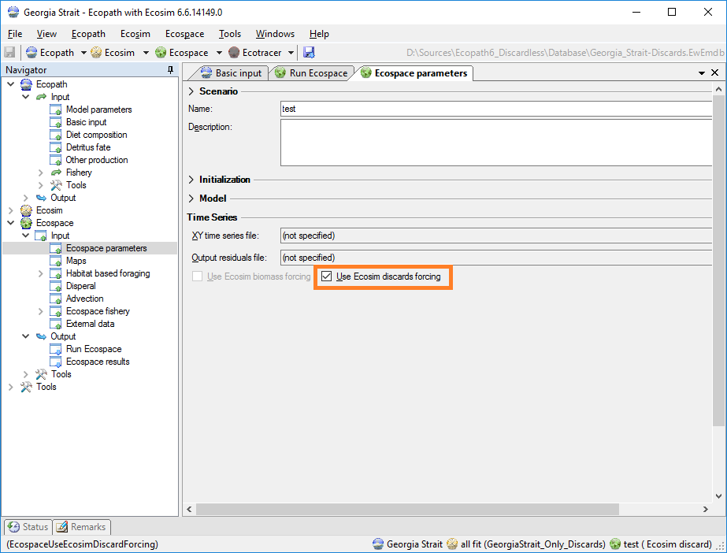  Figure 6 - Enabling Ecosim discard forcing in Ecospace |  | 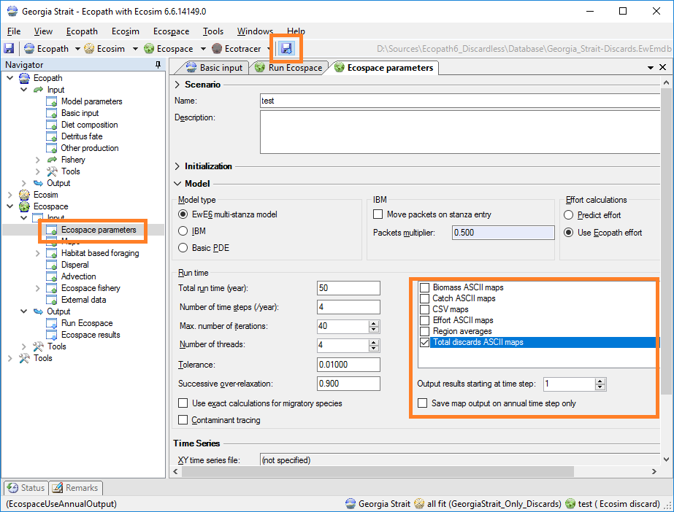  Figure 7 - Enabling automatic Ecospace discard map saving

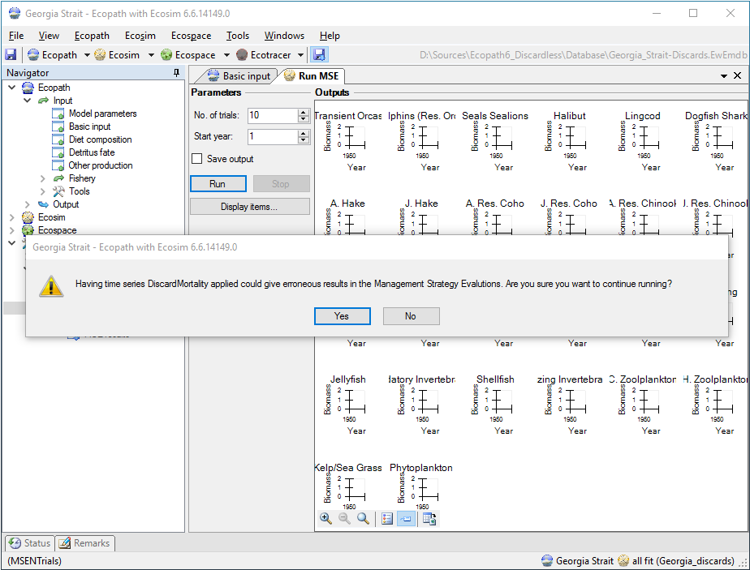
Figure 8 – The warning that either MSE routine will display when running with discards time series

Management Strategy Evaluations
The new Ecosim discards driver logic may conflict with the internal workings of the two Management Strategy Evaluation (MSE) routines in EwE, which already contain sophisticated discard management and assessment logic. In order to avoid Discard accounting conflicts within these routines, the EwE software user is now warned about potential conflicts when running either MSE routine with Discards driver time series present (Figure 8).

Release notes
EwE 6.6 is a preview version, which contains several additional features that are under development and should be considered unfinished. Development efforts in EwE 6.6 have been focusing on contaminant tracing and spatial-temporal advection; these altered systems should not interfere with testing for discards accounting. However, please use this version with care.
Note that any model opened up with this new version WILL update the structure of the model to the latest EwE 6.6 format. You may not be able to use these models with EwE 6.5 any longer. Please make sure you backup your models before opening them with EwE 6.6 Discardless preview.

